## Barometric Height Measurement combined with Map-Matching and Kalman-Filtering

Riccardo Orion Feingold

MN Department

High School of Kirchenfeld, Switzerland

riccardo.feingold@kinet.ch

***Abstract -* In this paper a location estimation algorithm is briefly presented - especially focused on the vertical position. The idea is based on the combination of a Map-Matching algorithm and a Kalman Filter. Both are implemented in a altimeter, which consists out of a GPS shield and a sensor. While the GPS is giving the x,y and z coordinates as well as the velocity, the sensor can measure the temperature, pressure and the altitude over mean sea level (MSL) by using the so called international height formulae (or another one). The goal of this paper is to introduce some basic knowledge and to give a short answer on to the question: How can the vehicle’s positioning be improved?**

1. INTRODUCTION

Over the last years, vehicle positioning becomes more and more important, since many emerging implementations - such as car, train and plane traffic - rely on accurate vehicle location information (x,y and z coordinates), which are in reality not always accurate. Therefore, the theme of my Maturapaper is covering the question: How can the vehicle’s position accuracy be improved for all kinds of situations, where measurement uncertainties occur? The short answer is: “Sensor Fusion”.

According to Techopedia dictionary “Sensor Fusion” can be defined as “[…] the use of sensory data from multiple sources, combined into one comprehensive result.”1 This means: “Using multiple sensors, planners can generate more robust data models or obtain greater numbers of data points for the purposes of a given system.”1 In other words, sensor-fused based systems combine the advantages of all the used sensors with the idea of making it better than each sensor alone.

This essay will provide a small theoretical framework based on [1], [2] and [3] for my practical work which is the investigation of the height accuracy of the GPS, the barometer and the GPS-Barometer-System (sensor-fused version).

1. BAROMETRIC ALTIMETER VS. GPS [1]

The height estimation from the GPS is not in all situation accurate, so does the barometric altimeter too. All the outcoming results are always affected by external influences. In case of the GPS, such disturbances are basically everything which can block, reflect or even absorb GPS signals - e.g. dense infrastructures. In contrast with this, the height estimation of the GPS gets more accurate the more satellites it can accept - it needs at least four to estimate a height. According to the article [1] the standard deviation of the error of the estimated height is often more than 10m - in other words: GPS is in general not really accurate!

As a comparison to the GPS, the external disturbances of the barometric altimeter are mainly based on the weather’s condition. In stable conditions the barometer is giving surprisingly precise results. Unfortunately, never is the weather constant for long periods of time, so in order to afford accurate altitude measurements, barometric altimeters are calibrated frequently to correct for atmospheric pressure variations. Fig. 1 [2] displays the absolute height estimation error (|hmeasured - htrue height|) for the GPS and the barometric altimeter. “The height estimates provided by GPS (denoted by GPS) exhibit the largest errors compared to the other approaches. […] The absolute error of the unﬁltered barometric measurements (denoted by BARO) achieves an average error of about 5 m.”[2]

Fig. 1: Absolute height estimation error 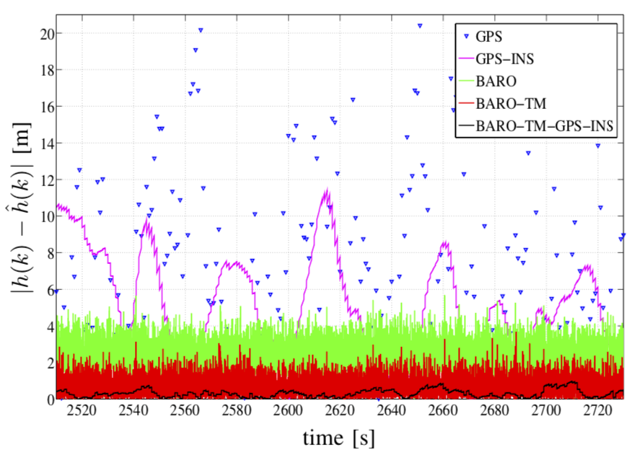

It clearly shows that an improvement of the sensors must be done. As a conclusion, both ways are showing good results, but only in rare and specific cases as mentioned before, thus there are reasons why fusing barometer with GPS (Sensor Fusion) can be a way to overcome those disturbances.

1. MAP-MATCHING [2]

The Map-Matching algorithm improves the barometric height estimation by using topographic information. This information is stored in a dataset, which contains so called fixed-points, therefore, positions where the true height is known. Thus, if the current horizontal position corresponds to a location, for which height data is available, it is possible to primarily calibrate the barometric altimeter and secondly the height reading from the dataset and the measured height can be used for determining the current error in the measurement. To sum up, the more exact height values the system has in its dataset, the more calibration steps can be done and therefore the more accurate becomes the barometric altimeter. Since Map-Matching works only in combination of a GPS module and a barometer, therefore a system based on the idea of “Sensor Fusion” is needed.

1. KALMAN-FILTERING [3]

The Kalman-Filter is able to decrease the error in the height and position estimation. To understand how it works, we first need to know what a filter actually is.

A filter according to the Cambridge dictionary is defined as “a tool for selecting or removing a particular type of informations”3. In case of the Kalman filter, it takes in information about the state2 dynamics which is known to have some error. Then by using this and the previous state, the filter predicts what the next state will be. In the update step, the predicted state will be adopted based on the measurements. The more accurate the measurements are the more emphasis is put on it and vice versa.

Kalman filters are ideal for systems which are continuously changing. They have the advantage that they are light on memory, and they are very fast. Furthermore Kalman-Filtering is working better if multiple sensor are used, because then it can determine via the covariance matrix whether there is a correlation or not among the sensors. To conclude with, the Kalman-Filter can be used for compensating unwanted variations - as mentioned in chapter II - and is an appropriate method when using multiple sensors, because it can improve all simultaneously, thanks to matrices.

1. CONCLUSION

The main objective of this paper was to provide a theoretical framework for my practical part. I have done this by showing that the “Sensor Fusion” of barometer and GPS combined with Map-Matching and Kalman-Filtering is a proposal for making vehicle positioning more accurate. This was important because, based on my theoretical part, I developed my GPS-Barometer-System to show that it is indeed more accurate than the GPS or the barometric altimeter. However, this will be part of my Maturapaper and not this essay.

**Vocabulary:**

|  |  |
| --- | --- |
| GPS | Global Positioning System |
| barometer | is a device for measuring the pressure |
| standard deviation | is a measure in statistics to quantify the amount of variations of given dataset |

1. BIBLIOGRAPHY

[1]Burgett, Scott et al.: *Method And Apparatus for Calculation Altitude Based on Barometric And GPS Measurement (2001)* <https://patentimages.storage.googleapis.com/b5/fa/3a/aebf34bdc779bc/US6735542.pdf> (fetched on the 27.03.19)

[2]Bevermeier, Maik et al.: *Barometric Height Estimation Combined with Map-Matching in a Loosely-Coupled Kalman-Filter* (2010) <https://www.researchgate.net/publication/224199908_Barometric_height_estimation_combined_with_map-matching_in_a_loosely-coupled_Kalman-filter> (fetched on the 25.03.19)

[3]B. Rhudy, Matthew et al.: *A Kalman Filtering Tutorial For Undergraduate Students* (2017) <http://aircconline.com/ijcses/V8N1/8117ijcses01.pdf> (fetched on the 06.05.19)

**Getting started: What was the most difficult?**

The most difficult at the beginning of this project was to find the right scientific papers which are contributing to my theme. It took me several weeks until I had my list of reliable articles. Additionally I also found difficult to implement them into a reasonable context, so with regard to the question: How do I structure my scientific paper?

**How did you overcome these difficulties?**

The documents on intern helped me a lot when bibliographing and quoting. Concerning the structuring, the script and also the step by step guide of implementing a scientific paper was a great aid by giving me a concret guideline.

**Working on your Science Paper: What was difficult? What was easy?**

The difficult thing when writing the paper was to be short, clear and precise in the formulation of the sentences. I saw that it wasn’t that easy to explain relatively complex theories in just a few sentences than I pretended. I namely recognized that I tend to write lots of elliptic sentences.

Although it was hard for me to write shorter and more precise, this doesn’t mean that I had problems in expressing my ideas and the ideas of the articles - it is this limit of 800 words, which made me the biggest problem.

**What to change?**

In the future I want to get better in compromising information and reflect them in short and simple formulations. Besides that, I also want to use more advanced sentence, like those we discussed in the grammar lesson.

**What to keep?**

I want to keep the newly acquired skills. Also worth to keep is this paper and the whole theory of “How to write a scientific paper?”.

**Conclusion**:

The MA week helped me to understand the complexity of writing reasonable scientific papers and gave me the opportunity to test my knowledge. Through the project I also found new helpful scientific papers, which in return gave me a better understanding of what I’ve already known.